SUPPLEMENT TO

WILLIAM AND NATHAN BULLARD FAMILY

HISTORY AND GENEALOGY

SEPTEMBER 2005
Updated: January 2007

BY

SPENCER ARDELL BULLARD

INTRODUCTION

Additional relevant historical information has been located since publishing the WILLIAM AND NATHAN BULLARD HISTORY AND GENEALOGY in February 2004. This Supplement documents that information as currently available to me.
I have corresponded with Jerome Tew, Edith Knott, and Sherry Welter while conducting this research. Jerome Tew provided the leads to locating the William BULLARD Revolutionary War Records and much of the information relating to his ancestor Revolutionary War Soldier Thomas BULLARD. Sherry and Edith have contributed to this work also.

WILLIAM BULLARD REVOLUTIIONARY WAR RECORDS

Records have been obtained from the North Carolina State Department of Cultural Resources, Office of Archives and History pertaining to Revolutionary War Service for William BULLARD. The records include: (1) Muster/roster records for North Carolina Militia Service, Wilmington District, for the period 16 July 1783 to 10 March 1784; (2) Pay voucher for this period of service; and (3) A contract or invoice for the purchase of three hundred fifty (350) pounds of beef from William BULLARD by the NC Militia. The date of this purchase is not stated but was after 15 February 1780, the date stated for the Resolve of Congress in ascertaining the value of Spanish Gold Dollars used for payment. The Treaty of Paris signed Sept. 3, 1783 and ratified in December 1783 ended the War. Troops were discharged in March 1784. These records are included in Appendices A-Sup.

The William BULLARD identified in the records is believed to be, beyond a reasonable doubt, the William BULLARD who obtained land grants in 1760-1762 north of Goshen Swamp in Duplin County, NC. He was the father of Nathan BULLARD. An exhaustive study of other William BULLARDS who lived in the area has led to the conclusion that on this William BULLARD could have provided beef for the NC Militia and served in the NC Militia for the period identified. Service in the County Militia was customary for all eligible males at that time.

The only other William BULLARD known to be of possible military age was the one identified by Revolutionary War Patriot Thomas BULLARD in his Bible Records found in the NC State Archives. In these records, it is reported that Thomas, born in Virginia in 1759, came to North Carolina with his brother, William and two sisters, Easter and Penelope. They settled on the south side of South River near what is now known as Morris’s Ford, in what is now Cumberland County.

After the Revolutionary War Thomas and William moved to Sampson County and settled near what is known as BULLARD Branch near Little Coharie Creek. William died there and was never married.

Records of land ownership have not been found for this William BULLARD. Records of BULLARD Branch near Little Coharie cannot be found, although a BULLARD Pond is shown in the US Genealogical Survey places database. BULLARD Pond is located about two miles WNW of Roseboro in Sampson County on a branch that runs into Big Swamp. This is likely the BULLARD Branch referred to.

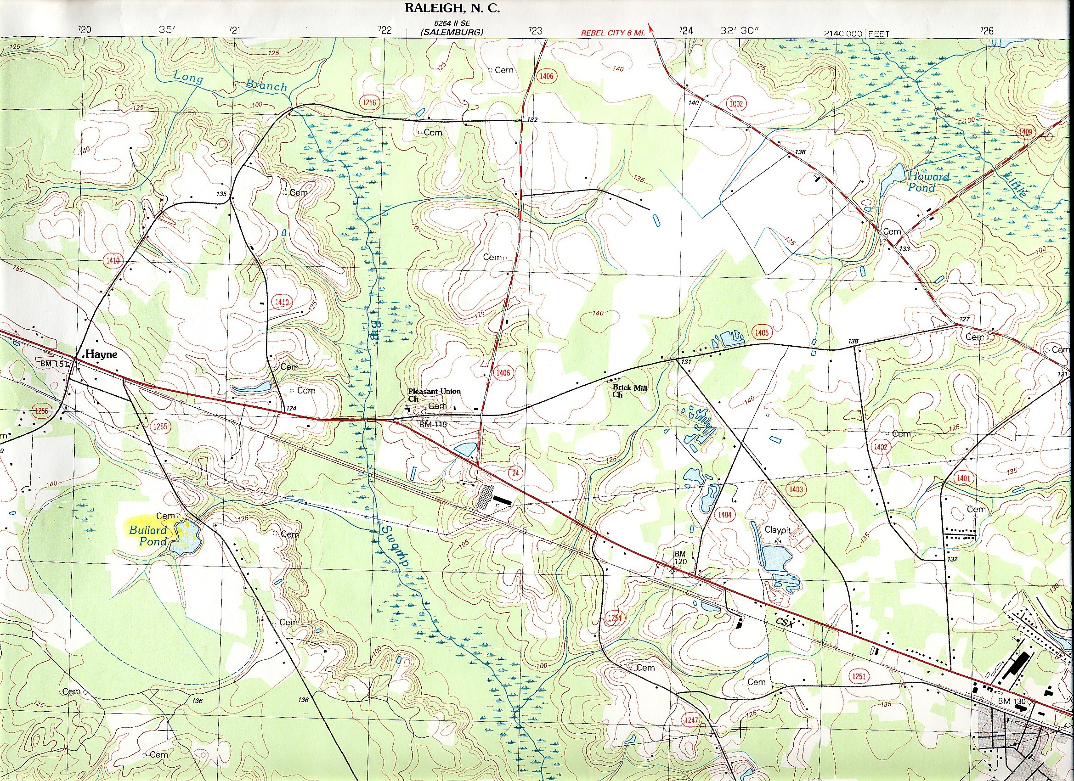

BULLARD POND AS SHOWN IN USGS ROSEBORO NC QUANDRANGLE MAP
Longitude grid lines are about 0.45 miles separation

The Revolutionary War Soldier Thomas BULLARD Bible records are the only records known for this William BULLARD. The area described is near Land Grants and land transactions for Jeremiah and an older Thomas BULLARD. This leads to speculation that there could be a relationship between all of these BULLARD Families in Duplin, Sampson, and Cumberland Counties. Sampson County was created out of the western side of Duplin County after the Revolutionary War in 1784.

SEARCH FOR THE ORGIN OF NORTH CAROLINA BULLARDS

In the search for the origin of the BULLARD FAMILIES of Duplin and Sampson Counties of North Carolina, I have compiled a Table shown in Appendix B-Sup. In table form it shows all BULLARD records with dates earlier than 1800 that I could find. It is limited to the Middle and South Atlantic States and surrounding area. Entries pertaining to Goshen Swamp Duplin County William BULLARD have been highlighted in Table.

Appendix C-Sup is a reprint of the FOREWORD and LINEAGE Sections of a booklet THE BULLARDS OF NORTH CAROLINA BY E. M. BULLARD published by Bass Publishing Company, Clinton, NC 1957.

In the Foreword E. M. BULLARD identifies himself as a descendant of the Revolutionary Soldier Thomas BULLARD and discusses his research into the relationship of his ancestor with other BULLARD Families who lived in Duplin and Sampson Counties, NC. His booklet presents the details and discussion relevant to his research. He concludes that positive proof of relationship was not found but that reasonable solution was uncovered. He believes the BULLARD Families residing in Duplin and Sampson Counties NC during and shortly after the Revolutionary War are likely related and likely descend from Jeremiah BULLARD who was born in Dedham, MA in 1702.

My research has examined the evidence provided by E. M. BULLARD research provided in his booklet. I have found nothing that would contradict his conclusion. However some details relating to the presence of Robert BULLARD in the Goshen Swamp area in the 1760s were not found. The Land dispute between Andrew Bass and BULLARD in 1760 was with our William BULLARD and not Robert BULLARD as E. M. had indicated. I have documented that fact in my WILLIAM AND NATHAN BULLARD FAMILY HISTORY AND GENEALOGY book published February 2004.

CONCLUSIONS

I draw three conclusions from my research:
(1) William BULLARD identified in the Revolutionary War Records should be included in the DAR BOOK OF PAAATRIOTS since both periods of service appear to qualify him according to the criteria stated for inclusion.
(2) That the William BULLARD who settled on a Land Grant in 1760 north of Goshen Swamp in Duplin County, NC is the William BULLARD identified in the Revolutionary War Records.
(3) That the evidence is very strong and likely true that this William BULLARD of the Goshen Swamp area of Duplin County came to North Carolina with Jeremiah BULLARD about 1745-1755 by way of Dedham, MA and Virginia. This is compatible with the findings stated by E. M. BULLARD in his Booklet. The evidence is strong that this William is related, perhaps a son or brother, of Jeremiah BULLARD but positive proof of this has not been found.

APPENDIX A-SUP

WILLIAM BULLARD

REVOLUTIONARY WAR RECORDS

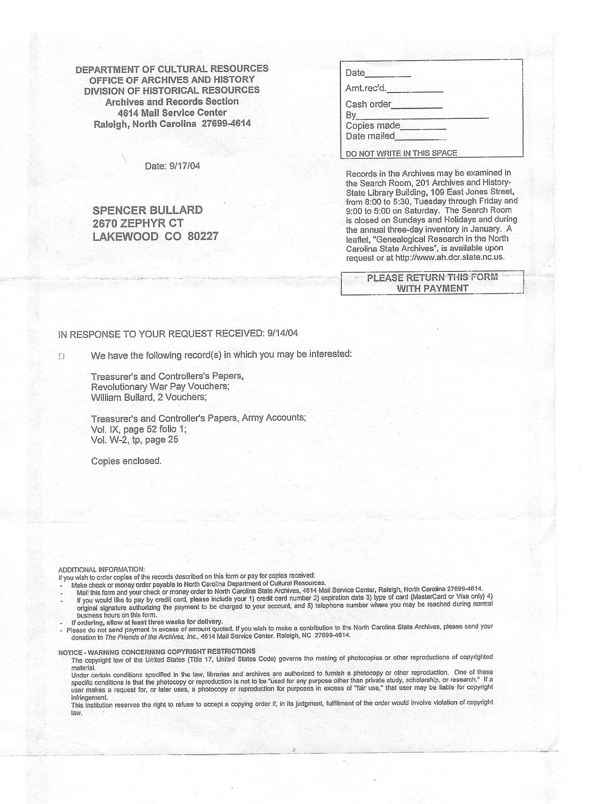
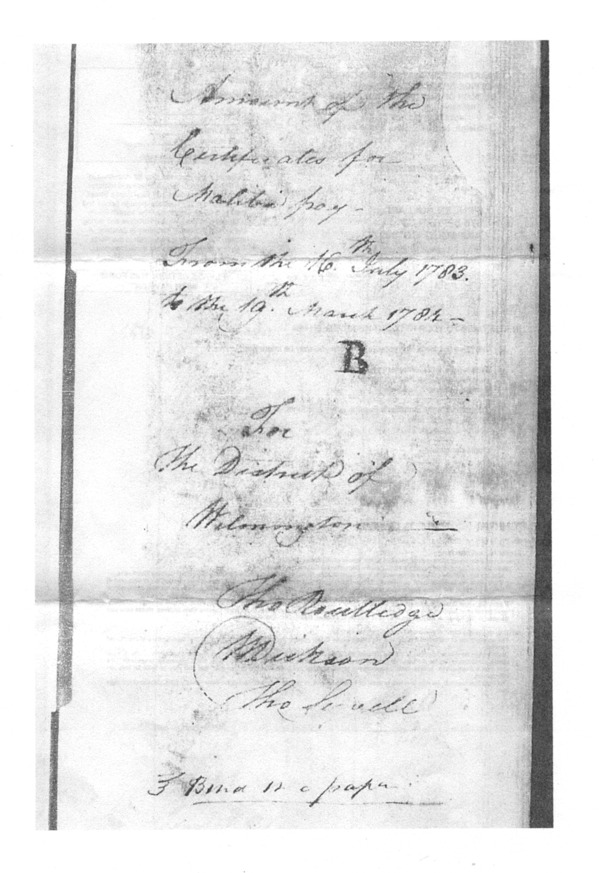
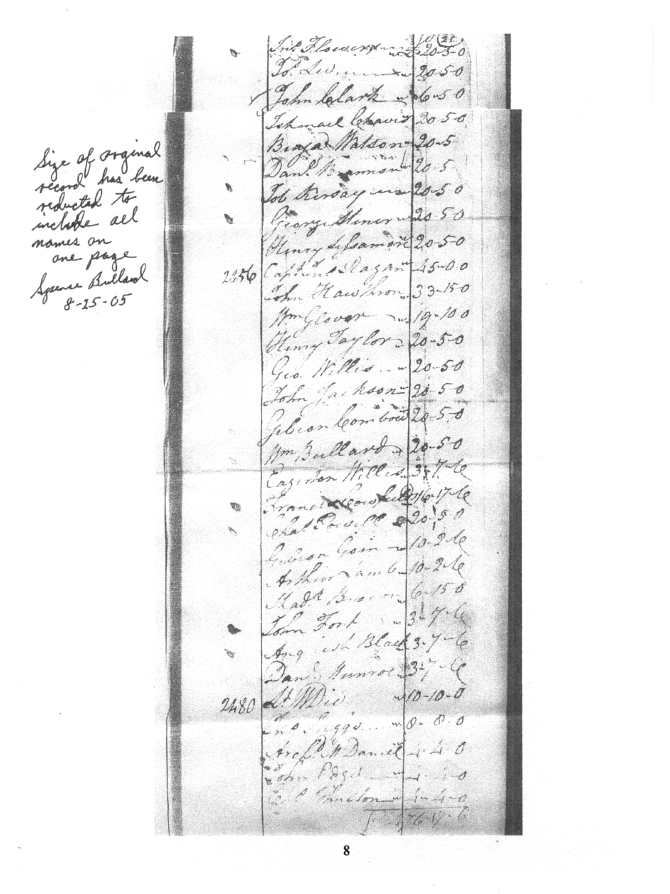
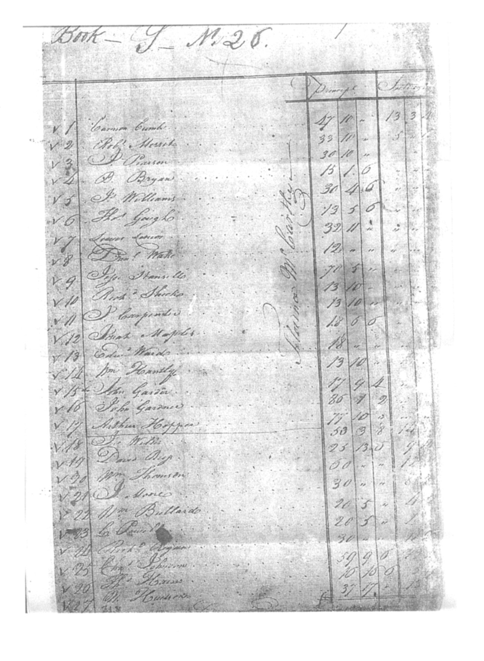
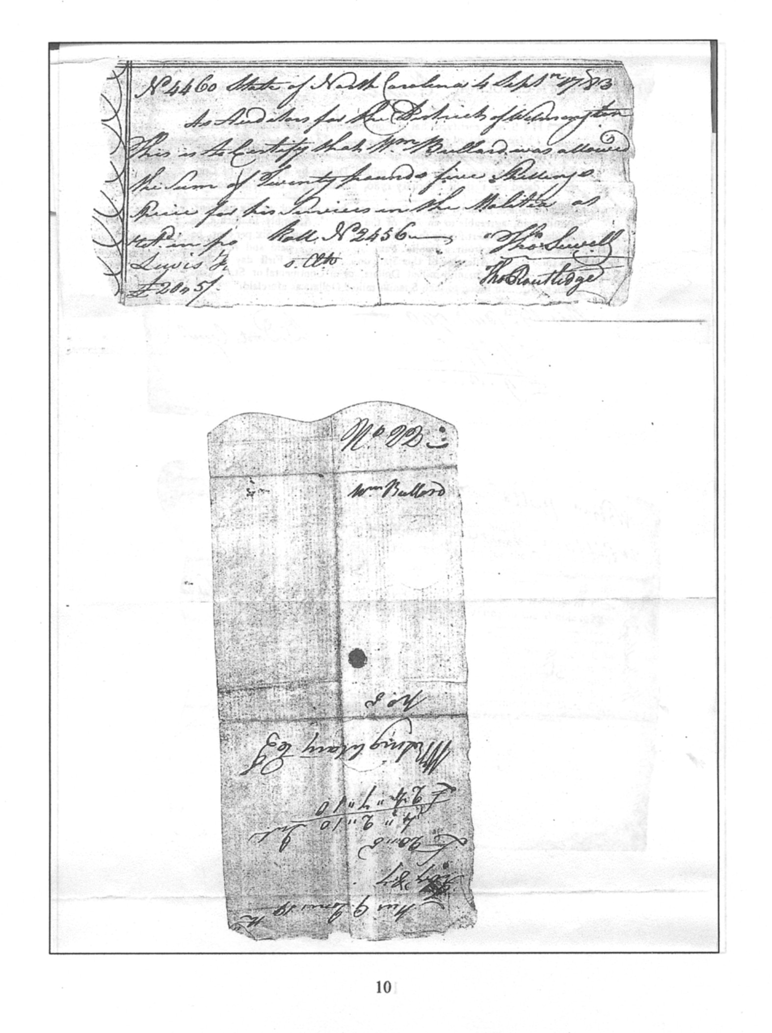
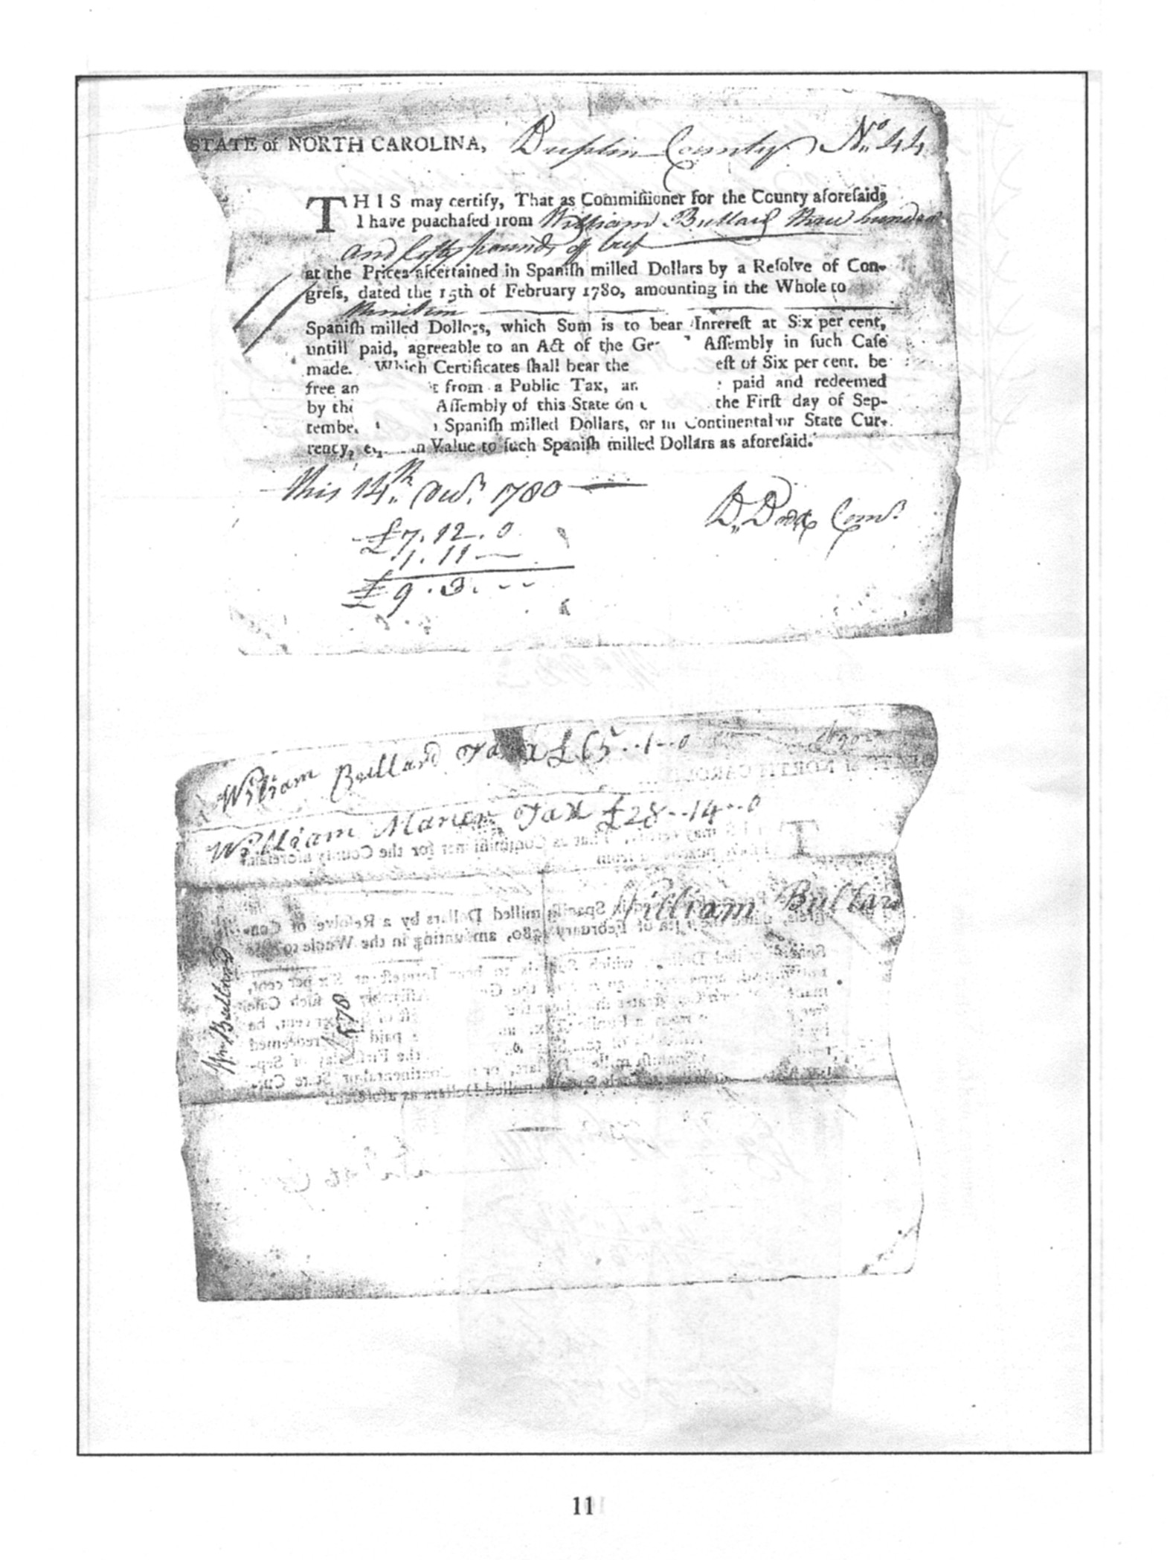

APPENDIX B-SUP

CHRONOLOGY OF EARLY BULLARD FACTS

CHRONOLOGY OF EARLY NC BULLARD FACTS FROM VARIOUS SOURCES
PRIMARY FOCUS IS ON WILLIAM AND THOMAS BULLARD AS NC REV. WAR SOLDIERS
COMPILED BY SPENCER A. BULLARD, JUNE 25, 2005

DATE | NAME | PLACE | SOURCE | FACT OR COMMENT
August 21, 1635 | Thomas Bullar | London, England | “The Complete Book of Emigrants” 1607 – 1660 by Peter W. Coldham. Page 163 | Thomas Bullar 32 among 144 names to be transported to Virginia by the George, Mr. John Severne, Captain, after examination by the Minister of Gravesend.
24 October, 1635 | John Bullar | London, England | “The Complete Book of Emigrants” 1661 – 1669 by Peter W. Coldham. Page 169-170. | John Bullar 32 among 51 names to be transported to Virginia by the jAbraham of London, Mr. John Barker, Captain.
28 June 1686 | Richard Bullard | London, England | “The Complete Book of Emigrants” 1607 – 1660 by Peter W. Coldham. Page 577. | Shippers by The Susan, Mr. Edward Tatmall, bound from London to Virginia. Richard Bullard, Thomas Jennings, Blewit Bemont. (PRO: E190/139/1)
1647 | Henry Bullard | Wanvick County, VA | The Virginia Genealogist, page 53 | Wanvick County, VA county court orders George Bramston to pay Henry Bullard 500 pounds of tobacco.
March 4, 1702 | Jeremiah Bullard born | Dedham, MA | Several –E.J. Bullard in “Other Bullards” | Birth date of Jeremiah Bullard son of William Bullard b. March 14, 1673 in Dedham, MA.
1705 | Thomas Bullard  son of Jeremiah ?? | Sampson County, NC | “The Bullards of NC” by E. M. Bullard | In description of land granted to Thomas Bullard, July 25, 1768 reference is made to original grant in 1705.
January 3, 1718 | Elizabeth Bullard | Virginia | The Virginia Genealogist, v4, pg 9 | Elizabeth Bullard was witness to a Will.
November 6, 1722 | Hopkin Bullard | Charleston, South Carolina | Abstract of Wills recorded in SC 1672-1730 by Janie Revill | Brother, Edward Bullard, a legacy and appointed sole Excr. Will signed at Philadelphia, and prov. at Philadelphia 6 January 1724.
15-25 May, 1725 | Richard Bullard | Maidstone, Kent, England | “The Complete Book of Emigrants,” 1725 by Peter W. Coldham. Page 341 | Richard Bullard aged 19 bound to James Gerald to serve 4 years in Jamacia; Richard Bullard was one of three names.
Abt. 1725 | William Bullard | Unknown | Assumed birth date | Assumed birth date based on assumed age of 35 when he received a Duplin County, NC Land Grant in 1760.
1725-1726 | Thomas Bullard  Robert Bullard | Virginia | Ambrose Madison’s Account Book | Both were named on two pages of Ambrose Madison’s Account Book. Ambrose was the Grand Father of President James Madison.
1735-1738 | Edward Bullard  Griffith Bullard  William Bullard | Charleston, SC | Index to personal names for SC Gazette, 1732-1738 | 32 entries for Edward; 10 entries for Griffith; and 1 entry for William Bullard in the Index.
1735 and later entries | Edward Bullard | Charleston, SC | SC Genealogical Society notes, pg 161 | Edward Bullard (a merchant, carpenter, and field marshall of the Troop of Horse Guards). References to several issues of SCG and SCHGM. Also PC, Will Book 1767-1771.
1737-1752 | Griffith Bullard | South Carolina | SC Genealogical Society notes, pg 161 | Griffith Bullard (a feltmaker) is referenced in PC, Will Book 1747-1752 and in SCG Feb 1735 and Feb 1737.
1738-1745 | Jeremiah Bullard | Virginia and North Carolina | “Bullard Newsletter” edited by Shirley Mofield, June 1998 | Per research published in June 1998 Bullard Newsletter edited by Shirley Mofield, Jeremiah migrated from MA to Va in 1738 and to NC in 1745.
1745 | William Bullard | Sulfolk County, England to Virginia | “The Complete Book of Emigrants in Bondage” 1644 – 1775 by Peter W. Coldham | A William Bullard was sentenced to Transportation to America for minor offences. During the season of Lent a ship of prisoners departed London for likely Virginia. No indenture time was given.
1746 | William Bullard  Thomas Bullard | Caroline County, Virginia | Colonial Carolina, A History of Caroline County, VA by T. E. Campbell | Page 400, In the Carolina Order Book for 1747 the names of William and Thomas Bullard are listed with debts of 0/1/6 and 0/0/2.5 pounds/shillings/pence respectively.
1750 | William Bullard | Caroline County, Virginia | Colonial Carolina, A History of Caroline County, VA by T. E. Campbell | Page 473, William Bullard among the names who served as a juror for the County Court during the year.
About 1753 | William Bullard | Caroline County, VA | Colonial Caroline, A History of Caroline County, VA by T. E. Campbell | Page 133, William Bullard among others fined for having too many tobacco plants. He was rearrested the following year, but an angered jury refused to convict those arrested.
August 20, 1755 | Jeremiah Bullard | South side Little Cohera, | “Bullard of NC”  E. M. Bullard | Purchased by deed a land tract between Little Cohera and South River in SW Duplin County, NC. It is assumed that this is the same Jeremiah who was born in 1702 in Dedham, MA.
October 10, 1755 | Thomas Bullard | Johnson County, NC | Colony of North Carolina 1735-1764, Abstracts of Land Patents, M. Hoffman | `914 Pg 144 Thomas Bullard, 10 October 1755 390 acres in Johnson County, NC on both sides of Norhunty including his own improvement, joining near the head of a small branch and the swamp.
October 21, 1758 | Jeremiah Bullard | Duplin County, NC | Colony of North Carolina 1735-1764, Abstracts of Land Patents, M. Hoffman | 6682 page 262 Jeremiah Bullard and John Parker 21 October 1758 200 acres in Duplin County, NC back of said Bullard and Parkers Home places joining John Brown, Little Cohera Swamp and a point near Alums Branch.
December 18, 1759 | Thomas Bullard | Virginia | “Other Bullards, A Genealogy”, by E. J. Bullard | Birth of Thomas Bullard as provided in his military records. He married Jemima Hall. He moved to Duplin County, NC with a brother William before the RW. He served in Sharps Company during the War. (see NC State Records, v16, pg 1024).
October 7, 1760 | William Bullard | Duplin County, NC | Duplin County, NC land records. | 150 acres on north side of Goshen Swamp near Gavins Foard. Was surveyed but never recorded. (See page 13, of “ William and Nathan Bullard History and Genealogy” by Spencer Ardell Bullard, February 2004.)
April 10, 1761 | John Bullard | Bladen County, NC | Joining the South Line | 5756 page 349 John Bullard 10 April 1761 100 acres in Bladen County, NC jo9ining the South Line.
April 10, 1761 | Ambrose Bullard | Dobbs County, NC | South side of Nauhunty Swamp joining Thomas Bullard | 5783 page 354 Ambrose Bullard 10 April 1761 150 acres in Dobbs County on the south side of Nauhunty Swamp joining Thomas Bullard, his own line, and the swamp.
November 15, 1762 | William Bullard | Duplin County, NC | Duplin County, NC Land Records | 315 acres on north side of Goshen Swamp about 5 miles above confluence with NE Cape Fear River. It includes a branch on the west end named Bullard Branch after him as original Land Grant owner.
July 25, 1768 | Thomas Bullard | Duplin County, NC | “Bullards of NC” by E. M. Bullard | Grant for land on south side of Little River. Refers to original patent grant in 1705. Thomas, the soldier, was age 9.
February 27, 1770 | Ambrose Bullard | Sampson County,  NC | “Bullards of NC”  E. M. Bullard | Received a land grant on the south side of Little River. (Book 3, page 498)
December 22, 1772 | Reuben Bullard | Caroline County, Virginia | “Bullard and Allied Families”, E. J. Bullard | Reuben, son of Reuben, born Dec. 22, 1772 in Caroline County VA, married 1803 to Elizabeth Gill
1772 | Robert Bullard Sr. | Sampson County, NC | “Bullards of NC” by E. M. Bullard | Robert Bullard, Sr. deeded a tract of land to Robert Bullard Jr. in Sampson County, NC on the South Side of Goshen Swamp.
February 15, 1780 | William Bullard | Duplin County?? | NC State Historical Archives | Revolutionary War Record showing William Bullard had provided the NC Militia 350 pounds of beef.
1783 | William Bullard  Jeremiah Bullard  Thomas Bullard | Duplin County, North Carolina | Duplin County 1783 Tax List | William Bullard – 46  Jeremiah Bullard – 143  Thomas Bullard - 31
July 16, 1783 to March 10, 1784 | William Bullard | Wilmington District of NC Militia | NC State Historical Archives | William Bullard included among several names identified as having served and authorized pay for service for in the North Carolina Militia for the period indicated.
September 4, 1783 | William Bullard | Wilmington District of NC Militia | NC State Historical Archives | A certificate showing William Bullaard was allowed pay for his services to the NC Militia.
December 6, 1785 | Jeremiah Bullard | Sampson County, NC | “Bullards of NC”,  E. M. Bullard | Conveyed land to Thomas Bullard, the Rev. War Soldier, located west side of Little Cohera River about 4 miles NW of Roseboro, NC. (This may be an assumption about RW Sold)
April 1786 | William Bullard | Duplin County | NC State Census for Duplin County | William Bullard included with 1 white male age 21 to 60; 2 white males of other age; 4 white females.
October 13, 1787 | James Bullard | Middle Prong, Buck Creek, Sampson | “Bullards of NC”,  E. M. Bullard | Bought from Jacob Mathews 550 acres (Book 11, page 195).  Can this be what is known as “Mathews Place” in reference to Thomas Bullard, the Rev. War Soldiers notes???
1790 | Thomas Bullard  Thomas Bullard  Jeremiah Bullard | Sampson County, North Carolina | 1790 Federal Census | Thomas Bullard – 1 male over 16, 1 male under 16, 3 females.  Thomas Bullard – 1 male over 16, 1 male under 16, 4 females.  Jeremiah Bullard – 2 males over 16, 1 female, 1 skave,
1800 | Richard Bullard  Thomas Bullard  Ambrose Bullard | Caroline County, Virginia | The Virginia Genealogist, v14, pg 83 | Richard, Thomas and Ambrose Bullard were listed in the Caroline County, VA Tax list.

Note: William Bullard born about 1725 and found in North Carolina in Duplin County, North Carolina Land Grants starting in 1760 (Highlighted above) is shown to be the only William Bullard in this area to meet all conditions of being the Revolutionary War Soldier as stated in the NC Revolutionary War Military Records in the Archives.

APPENCIX C-SUP

EXCERPTS FROM

THE BULLARDS FROM NORTH CAROLINA

BY E. M. BULLARD

1957

BASS PUBLISHING COMPANY, CLINTON, N. C.



