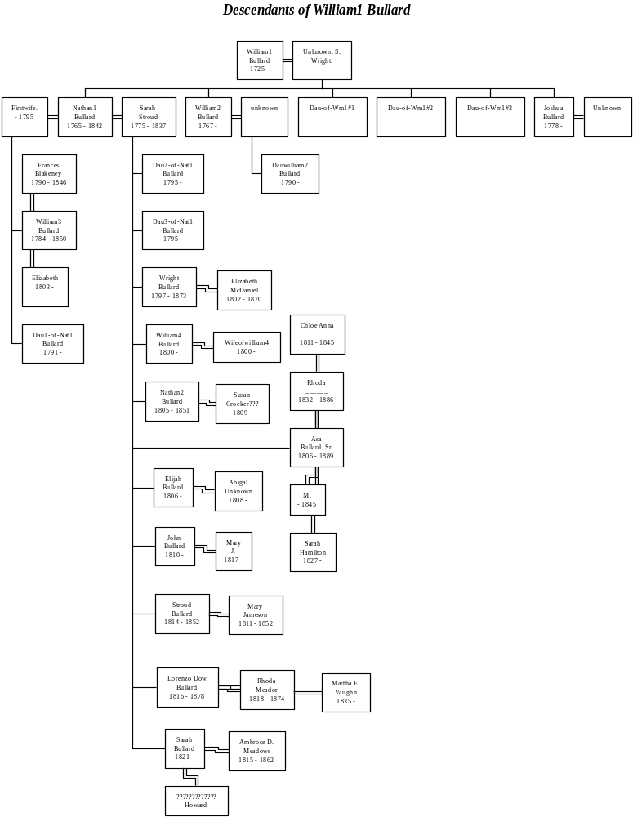

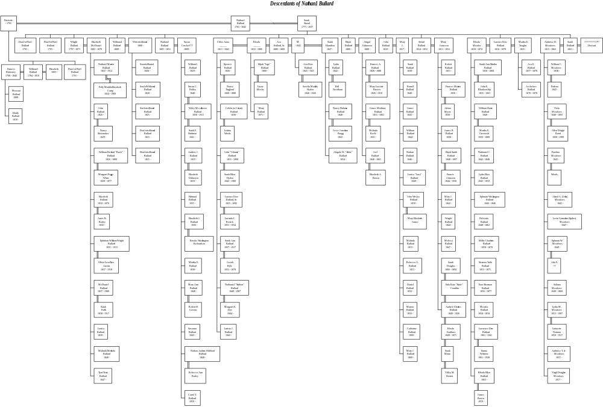

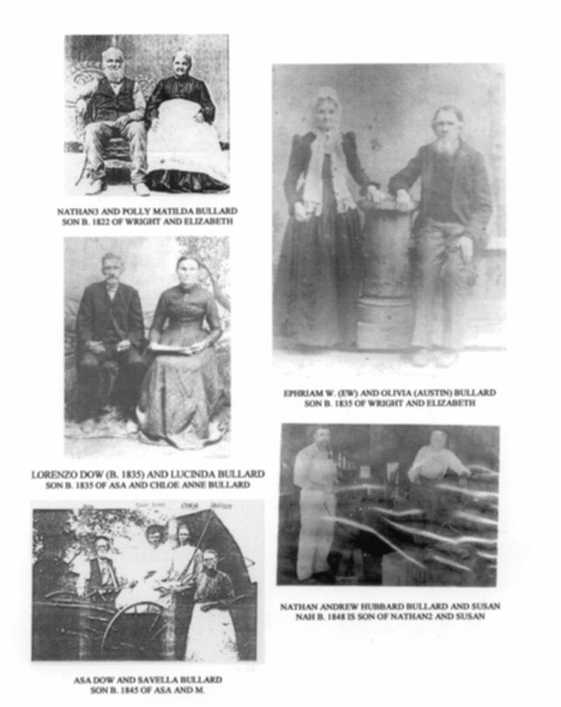

FIGURE 14 – GROUP 1 - THIRD & FOURTH GENERATION DESCENDANTS’ PICTURES

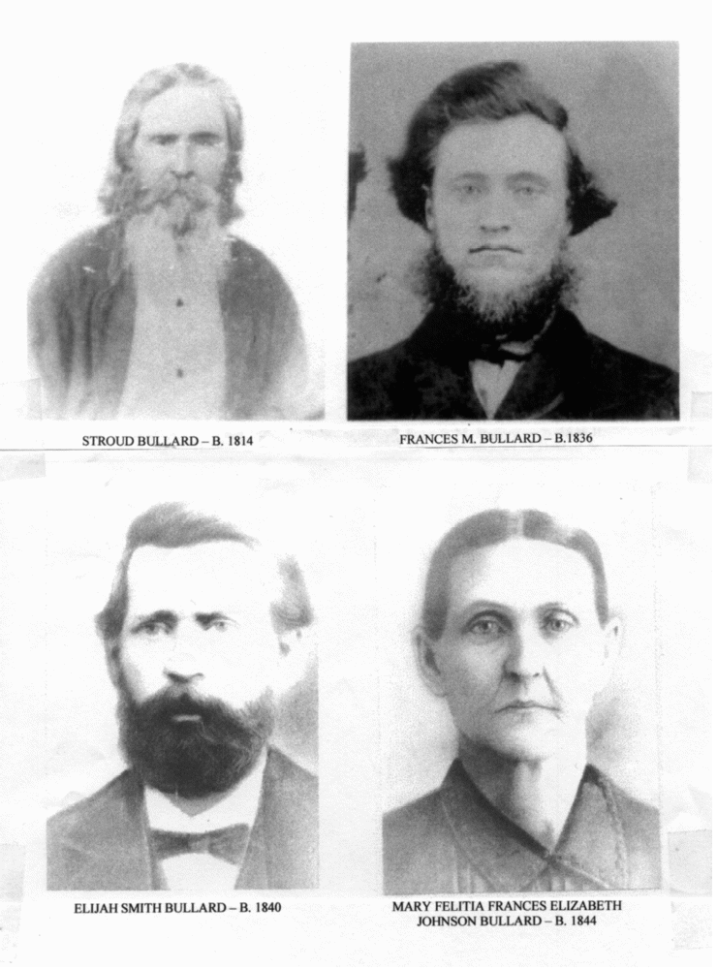
FIGURE 14 – GROUP 2 - THIRD & FOURTH GENERATION DESCENDANTS PICTURES

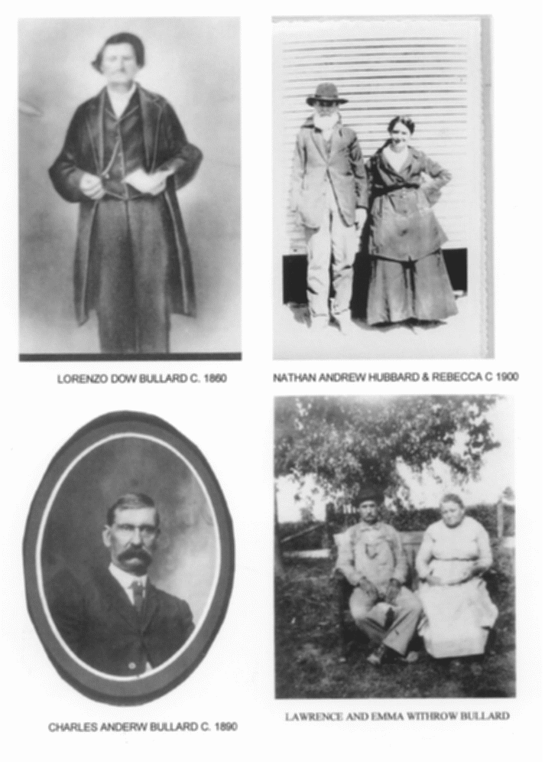

FIGURE 14 – GROUP 3 - THIRD & FOURTH GENERATION DESCENDANTS PICTURES
WILLIAM AND NATHAN BULLARD FAMILIES

